E-commerce Sales Performance & Customer Behavior Analysis
Project Objective:
The primary objective of this project is to clean, transform, analyze, and visualize an E-commerce store dataset using Microsoft Excel. By performing descriptive, diagnostic, predictive, and prescriptive analytics, the project aims to identify top-performing product categories, analyze customer purchasing behavior, assess regional sales distributions, and build an interactive dashboard to drive data-informed business strategies.

Dataset Description:
The dataset contains transactional records from an online retail store, including details regarding customer demographics, order dates, product categories, quantities sold, unit prices, total revenue, and shipping details.
Column Description:
Column Name | Description
Customer ID | Unique identifier for each customer
Age | Age of the employee/customer
Gender | Gender of the customer
Order Date | Date on which the purchase was made
Product Category | Category of the purchased item (e.g., Electronics, Clothing)
Quantity | Number of units purchased in the transaction
Unit Price | Selling price per single unit
Total Amount | Total revenue generated from the order (Quantity $\times$ Unit_Price)
Region | Geographic region where the customer is located
Payment Method | Payment mode used (Credit Card, UPI, PayPal)

Data cleaning & transformation:

*using find & replace in country and cust-id and removing duplicated value.
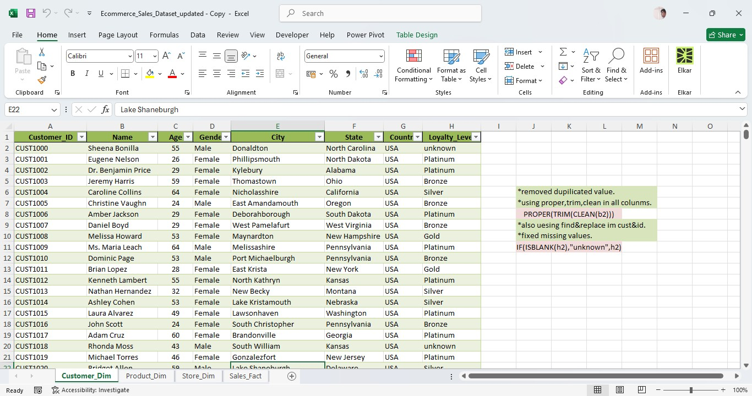
*combine 4 tables in 1 table and remove dupilicated values and also description statistics.

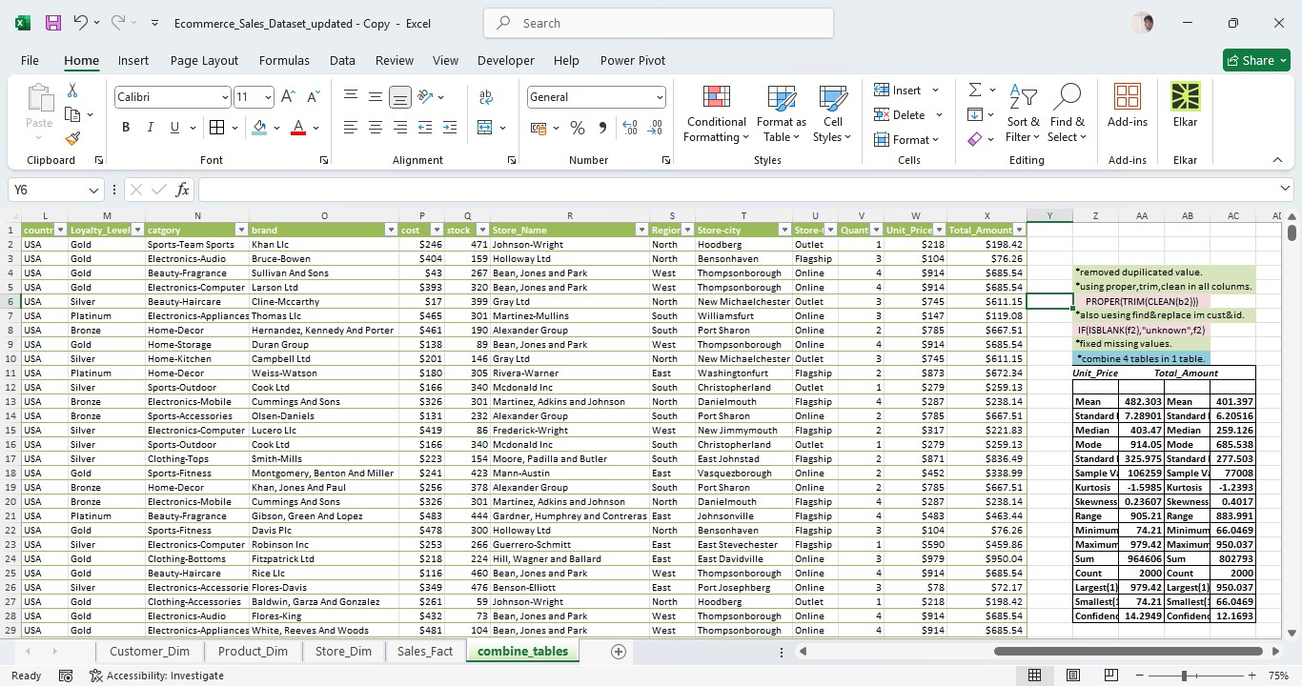

*using proper,trim,clean in all colunms ,also cust -id fixed in find&replace.

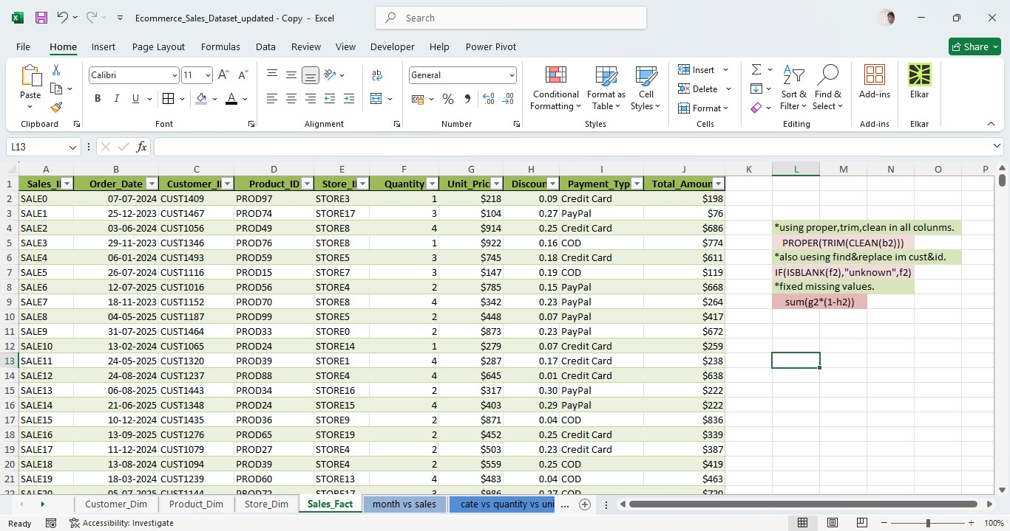

*using proper,trim,clean in all colunms
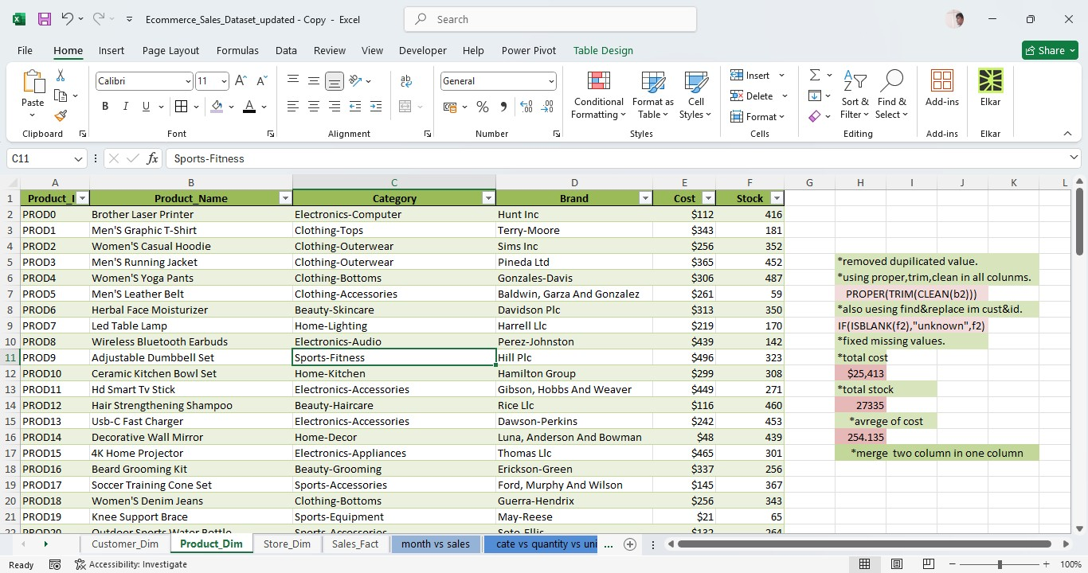

Formula used:
With screenshot
*fixed missing values (IF(ISBLANK(h2),"unknown",h2) )
* use proper,trim,clean(PROPER(TRIM(CLEAN(b2)))

*4 tables combine in 1 one table using xloop formula(XLOOKUP(F2,sales[Sales_ID],sales[Unit_Price],"not",0,1))

*fixed missing values in total amount column (sum(g2*(1-h2)) ana Quantity column (if(isblank(f2),average(f2:f2001),f2).

*total cost(sum(e2:e101),total stock(sum(f2:f101),average of cost(average(e2:e101).

Visualization and Insights Arrived with screenshot of visualization
Report/Dashboard screenshot:

- Descriptive analysis: what is the total sales by category?
Answer: Home-Decor – $75,106.26
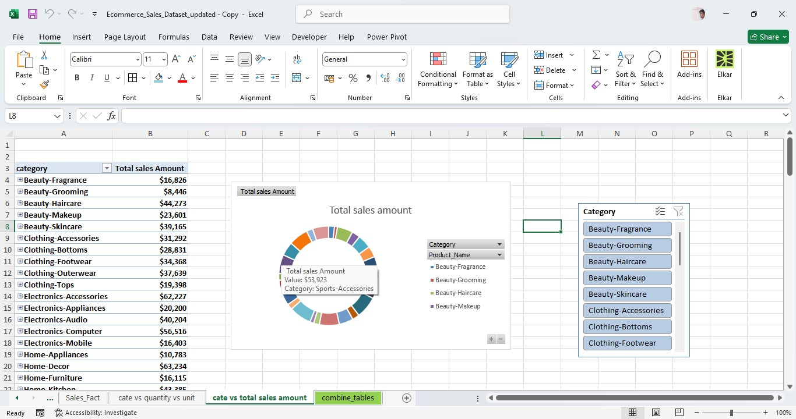

- Diagnostic Analysis:
Why does one category have higher sales than the other categories?
Answer: Home-Décor better for other products total home décor orders 139+ $540.33 average order value.
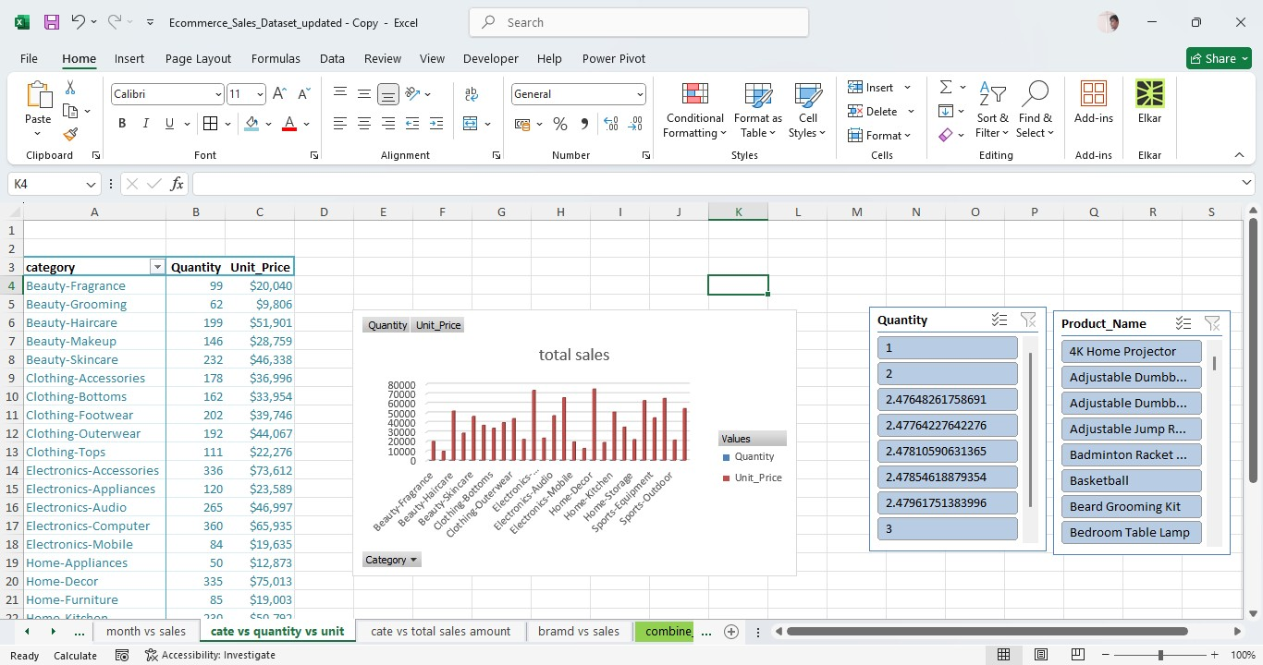
- Predictive Analysis:
Based on previous monthly sales, what could be the sales trend for the next month?
Answer: Sales may continue to high.
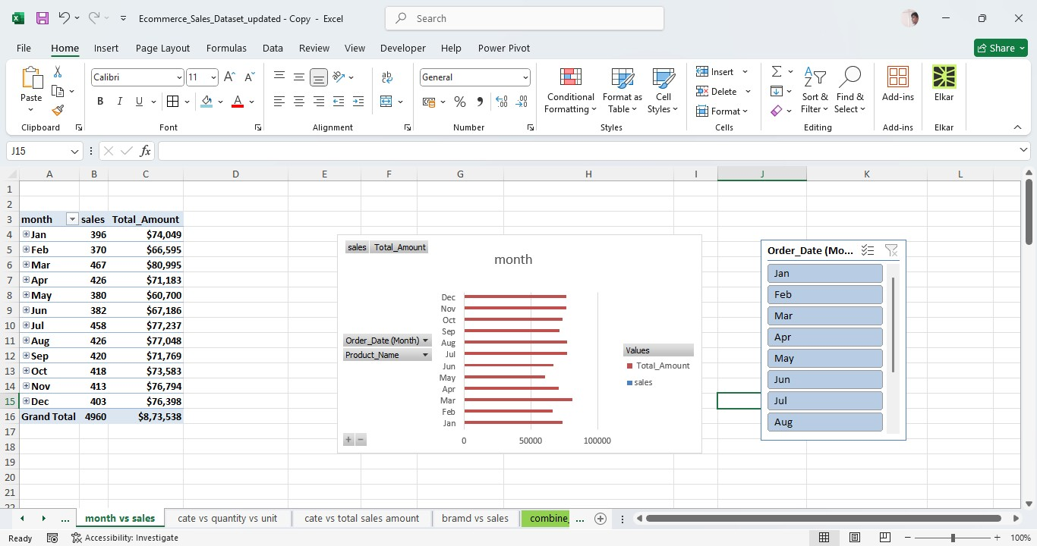
- Prescriptive Analysis:
Which category should the company promote more to increase sales?
Answer: Home-Décor promote more to increase sales.
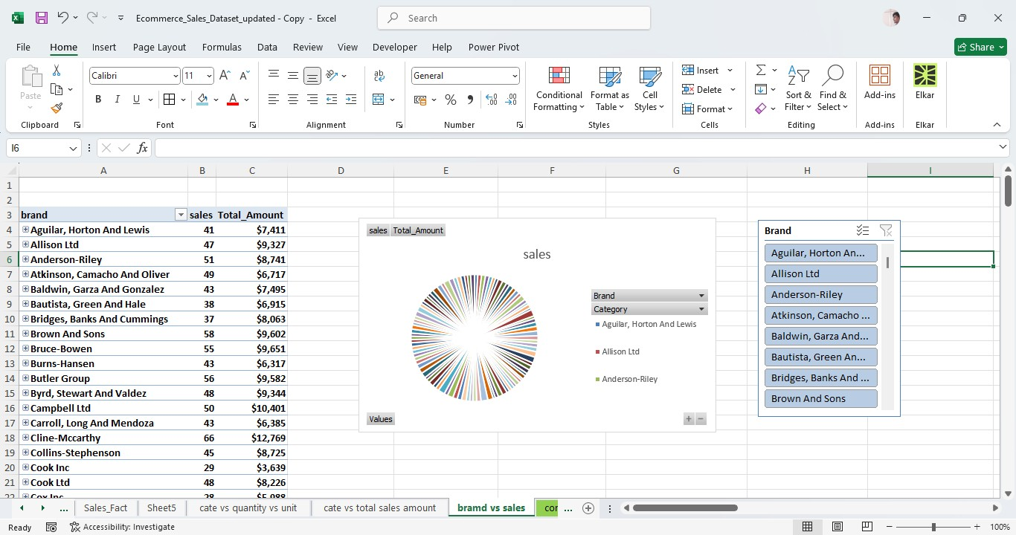
Dashboard Image:
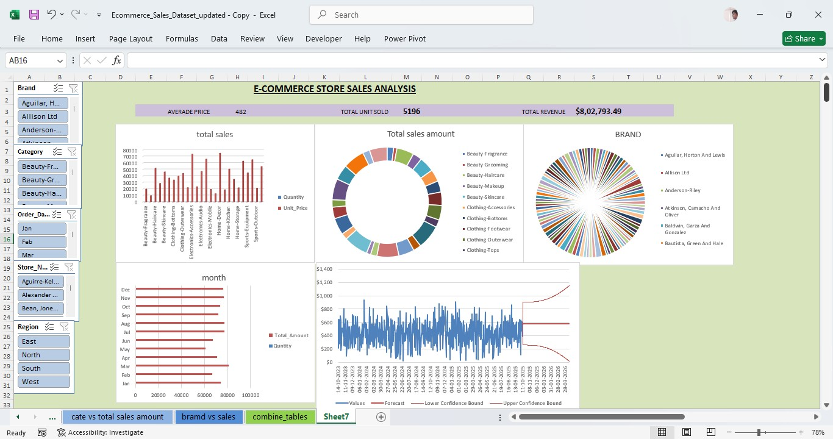

Final 4 type of insights as storytelling:
Descriptive | Home-Decor has the highest sales at $75,106.26.
Diagnostic | Home-Decor leads because it has more orders and a high average order value.
Predictive | Sales are expected to continue high future..
 | Prescriptive: company promte more sales Home-Decor to increase sales because home décor is high order.

Conclusion: Home-Decor is the best-performing category, with the highest sales.also high sales.so compamy focus home-deor .

